**S.R. INTERNATIONAL ACADEMY**

**GAJPUR, BANSPAR, GORAKHPUR**

**PRE- MIDTERM EXAM**

**SESSION 2024-25**

**CLASS – 2ND**

**SUB- COMPUTER MM:40**

**Q.1. Tick the correct option: 1x8=8**

**1.**A computer is a/an .........................machine.

a) conical b) electronic c) simple

**2**.This part looks like a television.

a) CPU b) Monitor c) Notepad

**3.** The desktop computer can be kept on the......................

a) palm b) table c) Lap

**4**. A........................has a touch screen display.

a) tablet b) laptop c) palmtop

**5.** It is also known as thebrain of the computer.

a) CD b) UPS c) CPU

6. ........................can be kept on our lap?

a) palmtop b) tablet c) Laptop

**7.**This part keeps the computer ON when the electricity goes off.

a) CPU b) DVD c) UPS

**8.**This part is use to store information.

a) joystick b) Hard disk c) Mouse

**Q.2. Fill in the blanks: 1x8=8**

**slower, scanner, mouse, Pendrive, palmtop, VDU, buttons, feelings, electronic, desktop**

**1.** The computer is an _____________ machine.

**2.** Amonitor is also known as_____________.

**3.** A ______________computer can not be movedfrom onr place to another easily.

**4**. ______________ computer can be kept on the palm.

**5.** A mouse has two______________ and a scroll wheel.

**6.** The _____________ is use for selecting objects on the screen.

**7.** Human beings work ______________than computers do.

**8**.______________ is also called Flash drive.

**9**.Human beings have _____________ but computer do not have any.

**10**. The _____________ copies the text and pictures from a page onto the computer.

**Q.3. Write (T) for true and (F) for false 1x8=8**

**1.**WordPad is a word processor program.

**2.** The pencil tool is used to draw freehand drawing.

**3.** The quick access toolbar contains the frequently used commands

**4.** We can draw curves using the line tool

**5.** To select a WordPad, triple click on it.

**6.** Polygontool is use to draw circles.

**7.** The windows control buttons are located at upper – right corner of the window.

**8.**we can type text in paint program.

**Q.4. Write the full form of the following: 1x5=5**

1.CD______________ 2. DVD __________________ 3. MS_______________

4. PC______________ 5. OS_______________

**Q.5. Write (YES) or (NO) for what you can or cannot do in MS paint: 1x8=8**

**1.**We cannot draw circles. __________

**2.** We can draw trees. __________

**3.** We cannot colour pictures. __________

**4.** We can type text. __________

**5.** We can draw a circle and fill colour in it. __________

**6.** We can play games. __________

**7.**We cannot draw aboat. __________

**8.** We can save our pictures. __________

**Q.6. Match the following 7x1=7**

**1.**Select line a) Double- click

**2.** Select a word. B) click

**3.**Long selection. c) Triple-a click

**4.** Select a paragraph. d)cursor

**5.** Text tool. e) Drag

**6.** Extension for WordPad f) write text

**7.** A small blinking line. g) .rtf

**Q.7. Name the following shape: 2x5=10**

1. 2. 3. 4. 5.

**_____________ ____________ ____________ _____________ _____________**

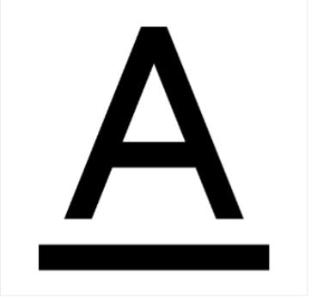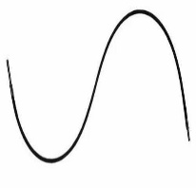**Q.8. Write the names of the following tools: 2x5=10**

**1. 2. 3. 4. 5.**

**____________ . _____________. _____________. ____________. _____________**

**Q.9. Answer the following questions: 2x5=10**

1. Write any 5 five components of the WordPad window.

2.What is the use of magnifier tool?

3.What does the title bar show?

4.Which tool will you use to erase a drawing?

5. Write main parts of the paint window.

**Q.10. Draw the mouse and write the name:4x1=4**